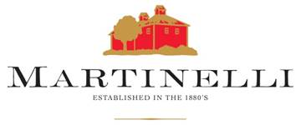

Regina Martinelli

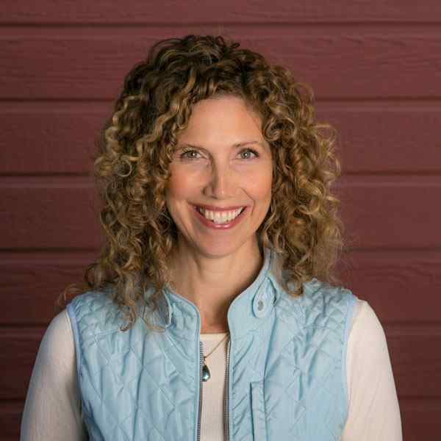

**Regina Martinelli**

**Owner / Sales/Marketing/Branding**

**Farming since: 1977**

Growing YeaRS & Character



Regina Martinelli is the youngest of the fourth generation of Martinellis working in wine. Anyone who’s spent five minutes with Regina can attest that she is overflowing with enthusiasm for the family business. “My favorite part of being a Martinelli is telling my family’s stories,” she recalls. “I never grow tired of going on the road sharing stories with people about the wines that my father worked so hard to make, and then coming home to share with him their delight.”

Growing up in a farming family, she was often left to work alone as the rest of the family was driving tractors. “Even as a young child, being in the vineyard was a serious matter and not playtime. I often had nothing but a sack lunch, my radio and the vines to keep me company. Looking back now, it was such an important experience because it taught me to entertain myself.”

After graduating from Cal Poly, she took a year off to live in Vail, CO. When she returned to California she was ready for city life, and found work in downtown San Francisco. She began taking night classes at University of San Francisco to obtain a Master’s Degree in Organizational Development, while consulting and training for various companies in the San Francisco Bay Area.

Upon Regina’s return to the winery in 2008, there was a need for additional help in marketing. She has since introduced many of the things she learned in corporate life, bringing the family business into the 21st Century. She began expanding consumer outreach to include wine cruises, open house events, library offerings and VIP tours and spearheaded the remodeling of the tasting room.

Outside of work, Regina spends time outdoors enjoying sports, particularly wakeboarding, hiking and snowboarding. Aside from a chocolate obsession, she is highly interested in nutrition and prefers unprocessed whole foods or raw foods. Regina also has a lifelong passion for coaching people. While living in the Bay Area she led women’s seminars for over 9 years. Today she is leading her own seminars and offering private coaching using NLP and transpersonal psychology practices…and raising her young son.