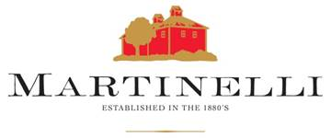

Lee Martinelli Sr.

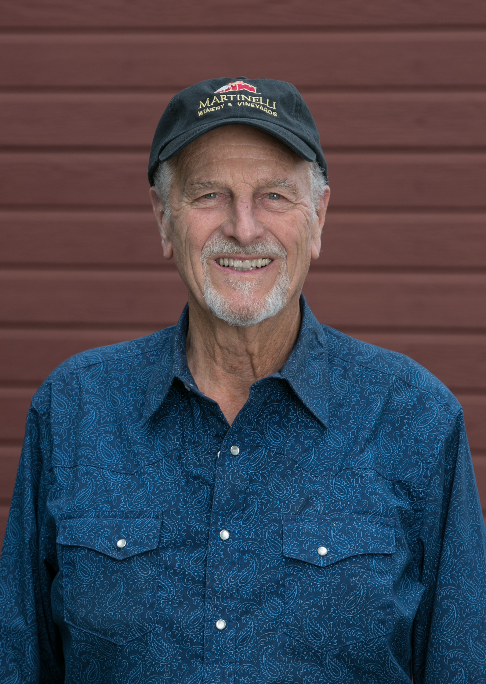

**Lee Martinelli Sr.**

**Owner / Farmer**

**Current Jackass on the Hill**

**Farming since: 1945**

Growing YeaRS & Character



Lee Martinelli, Sr. is the patriarch of Martinelli Winery, and the sole farmer of Jackass Hill. Jackass Hill, which is still home to the same vines that were first planted by his grandfather over 100 years ago, is known for having the steepest non-terraced vines in Sonoma County and was named because only a “jackass” would be foolish enough to farm it. “Everyone tells me Jackass Hill is too dangerous to farm, but I feel a responsibility to these vines. My father worked this vineyard every day for 75 years, and it has given so much to our family,” he says.

Born and raised in Sonoma County, Lee Sr. began working in his family’s vineyards and apple orchards at the age of six. He learned the value of hard work at a young age, sometimes having to work late into the night. “Even at the age of nine I was up working in the middle of the night. The Russian River Valley’s nighttime fog is great for grapes, but not very beneficial to sun-dried prunes, so I’d have to wake up at 2:00AM to pick them all up. It was the worst job, but years later it helped shape my own parenting philosophy.”

Initially, Lee Sr. studied Agricultural Business and Plant Science at Chico State, and received his teaching credential from UC Davis in 1967. After graduation he taught agriculture at Santa Rosa High School, and for the next five years he taught during the week while spending his weekends farming 17 acres of apples and grapes, and raising cattle.

In 1973 when Lee Sr. took over his Uncle Tony Bondi’s apple orchards and vineyards, he retired from teaching to focus full-time on farming. “I knew all along I wanted to work outdoors. I knew it would mean longer hours and harder work, but that is the price to pay for satisfaction. I learned to love the sense of accomplishment after a long day of farming, and the freedom of being in control of my own destiny”. Over the next decade, Lee Sr. went on to farm 450 acres of apples and grapes while serving as a board member for organizations like the Santa Rosa Sotoyome Soil Conservation District, Sebastopol Co-Op Cannery, Forestville Elementary School and Sebastopol Apple Growers United. He also received numerous awards including Outstanding Young Farmer of the Year in 1978, an award which both of his sons would later receive.