

Lee Martinelli Jr.

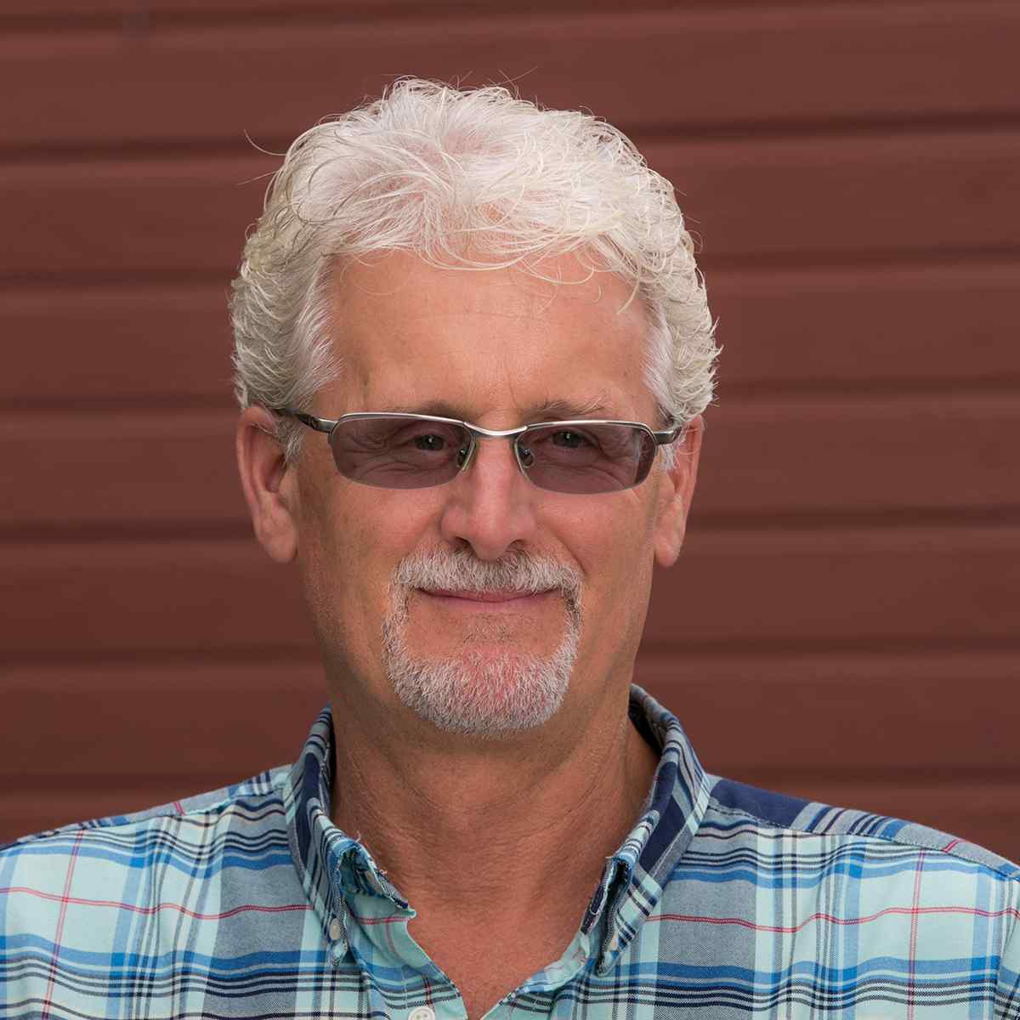

**Lee Martinelli Jr.**

**Owner / Farmer**

**Farming since: 1975**

Growing YeaRS & Character



Lee Martinelli Jr., a fourth generation farmer, was born in Sonoma County in 1964. At the age of eleven Lee was driving a tractor and running an apple crew in the family orchards. Throughout the years he worked with his father learning the art of viticulture. In 1989 he ventured out on his own and leased 17 acres of chardonnay vineyards on the Sonoma Coast (prime wild pig hunting ground) from his maternal grandfather, George Charles. In the years following Lee acquired and developed two vineyards of his own in the Russian River Valley. In 2004 Lee received the Outstanding Young Farmer of the Year Award from the Sonoma County Harvest Fair.

These days Lee works closely with his father and his brother in the vineyards as well as being active in the family winery with his sisters and mother. He currently farms his own vineyards and leases and manages others with the help of his wife Pamela. He has been a board member of the Russian River Valley Winegrowers Association from 2005 to 2014, served as president in 2008-2009, and is a member of the Russian River Valley Winegrowers Foundation. When he is not working Lee enjoys mountain biking, jeepin’, snow skiing, hunting, camping, and water sports at Lake Pillsbury with his family and friends, especially his 16 year-old daughter Maddy-Lu.