

Julianna Martinelli

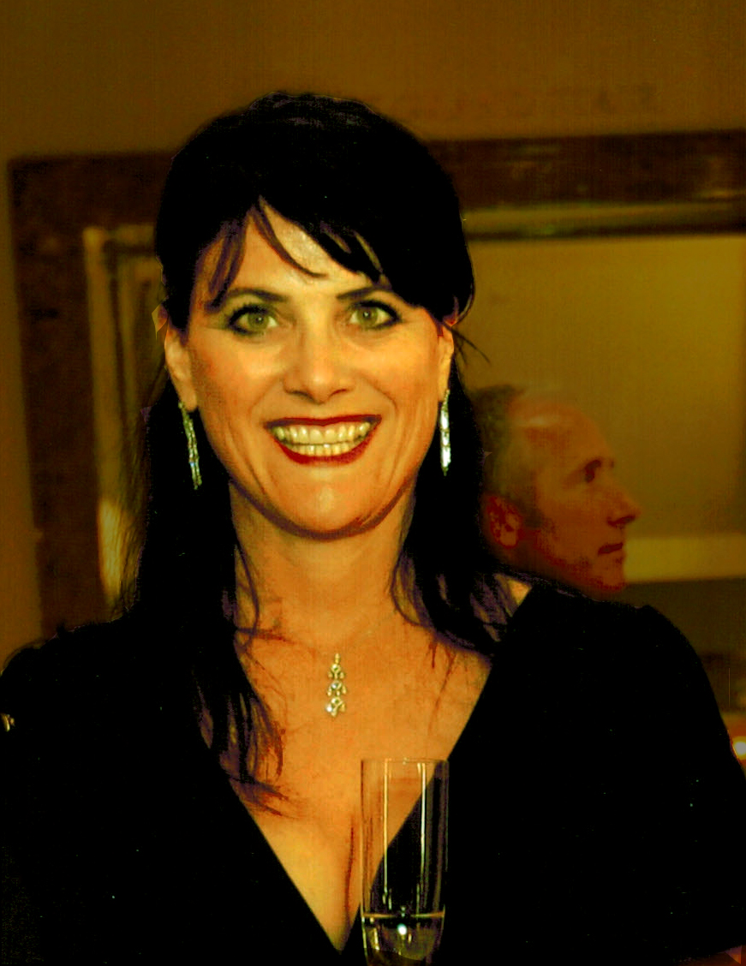

Julianna Martinelli

Owner / Sales & Marketing

Growing YeaRS & Character



Julianna Martinelli hails from the two horse town of Forestville, California, situated in the lush rolling hills of the Russian River Valley. She is the fourth generation in her family to be involved in the wine business. Julianna grew up on Martinelli Road surrounded by one-hundred year old Zinfandel vineyards which were planted by her great-grandparents, Giuseppe & Luisa, in the late 1800’s. She spent her childhood riding horses, raising sheep for 4-H, and fishing and swimming in the creek with her siblings and neighboring cousins.

Like the generation before, she began working in the vineyard at a young age. Julianna began the Sales and Marketing position for Martinelli Winery in 1993, while also writing the bi-annual newsletter. Martinelli Winery has become one of the industry’s finest wine producers and grape growers, focusing on the varietals of Chardonnay, Pinot Noir, Zinfandel, and Syrah. This small winery is family owned and operated, and the entire family has been involved in creating its success over the years. Julianna represents the winery at events across the United States and when at home she enjoys spending time with her three grandchildren.