

Carolyn Martinelli

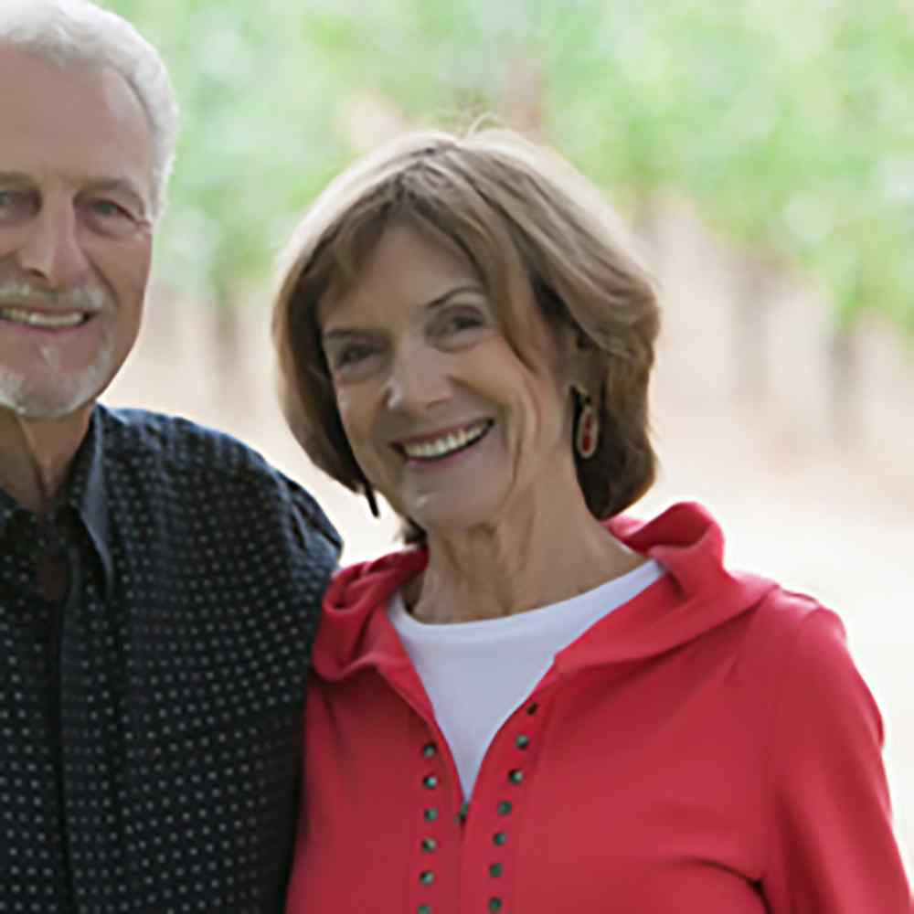

Carolyn Martinelli

Owner Winery & Vineyards

Growing YeaRS & Character



Carolyn grew up on the far Sonoma Coast helping her father, George Charles, raise sheep for wool. She often accompanied her father on horseback, riding her own horse at age 5, to help herd the flock. She attended the one-room school house in Fort Ross with several of her cousins. She moved with her parents to Dixon at 12 years old, because Dixon had better grazing lands for her father’s sheep. Carolyn went to San Jose State and the Santa Rosa Junior College, where she met Lee Sr.

Once Lee Sr. returned to farming after finishing school, Carolyn helped by hauling apples to the cannery and grapes to the wineries buying their fruit. In the later 1990’s, Carolyn and her two sisters, Charlotte and Donna, planted the Three Sisters Vineyards, in the Fort Ross – Seaview AVA, on our coastal property. In 2018, Lee Sr., Carolyn and their four children bought the two sisters out of this property.